**Scores in quiz**

**Unit 2 layouts**

**Cabillos John Antony P**

**Pathway 1**

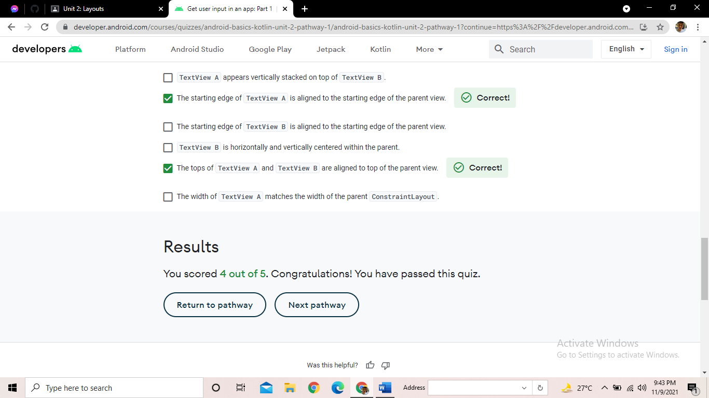

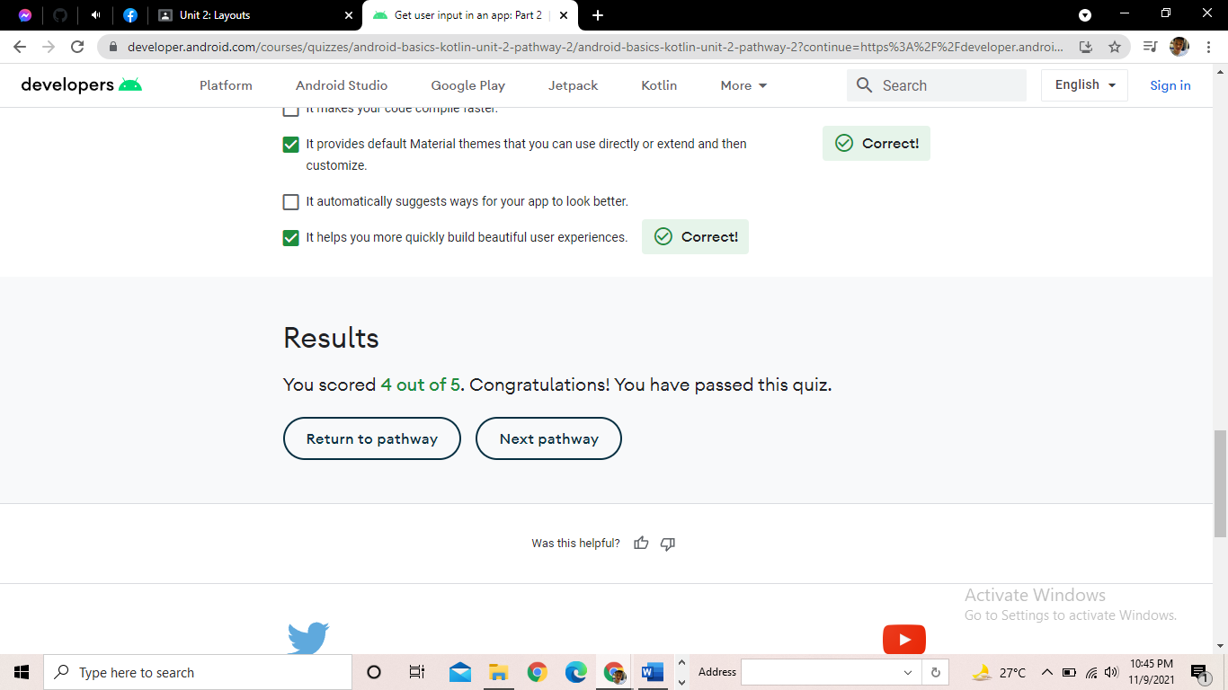**Pathway 2**

**Pathway 3**

